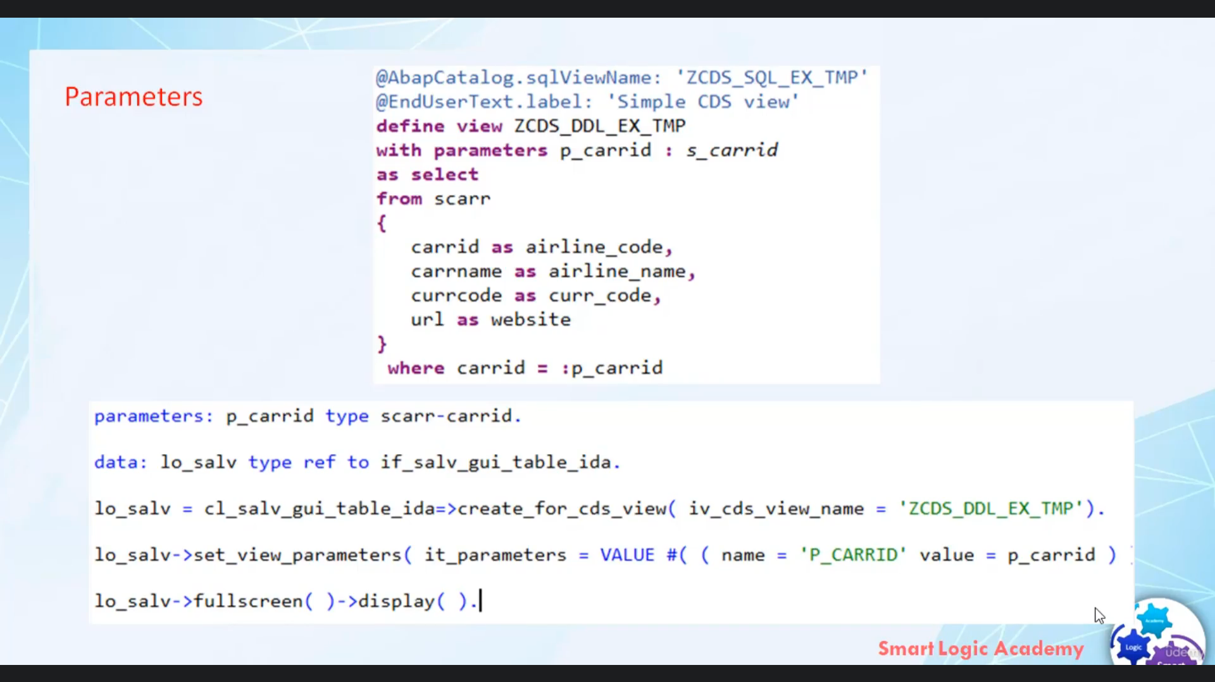

Hi, welcome back.

In this video, I will explain how you can use a vivid idea to display content in Arab cities with input

parameter.

So now let's stop.

Be Vitale can work with the issue that having put parameters in order for an application to supply value

for this input, parameters then must be passed to Illiad name value by calling me to say to barometer's.

If the data sources within good parameters, then Dimitar, safety parameters must be called the supply

value.

That's it for now, I hope you understood it.

Have a nice day.